**Canon EOS 6D Mark II (Body Only)**

|  |  |  |
| --- | --- | --- |
| Máy ảnh Canon EOS 6D Mark II (Body Only)  Canon 6D Mark II 1Canon 6D Mark II 7Canon 6D Mark II 6Canon 6D Mark II 5 |  | **Featured information:**   * Sensor: Full-Frame * ISO range: 100 - 40000 (expandable 50 - 102400) * Resolution: 26.2MP * Wireless connection: WiFi   **Price : 1200$**  **Specifications:**   * **Sensor Format:** Full-Frame (1x Crop Factor) * **Resolution:** 27.1 Megapixels * **Size photo:** 6240 x 4160 * **Image Proportions:** 1:1, 3:2, 4:3, 16:9 * **Sensor Type:** CMOS * **Image Format:** JPEG, Raw * **Anti-Vibration:** Digital, 5-Axis (Movie only) * **Lens Mount:** Canon EF |

**Description:**

#### **26.2MP Full-Frame CMOS sensor and DIGIC 7 image processor**

The 26.2MP Full-Frame CMOS sensor combined with the DIGIC 7 image processor on the Canon 6D Mark II creates extremely sharp and vivid images and videos. The machine's ISO sensitivity range can be expanded up to 102,400 - a pretty huge number in the price segment.

#### **Stylish Design**

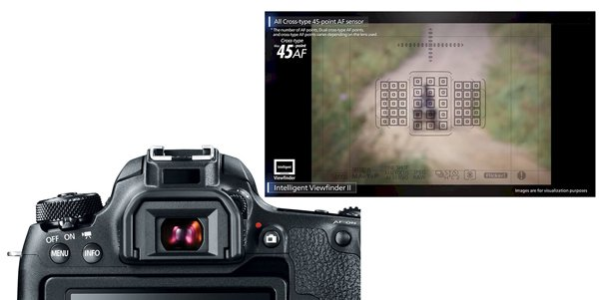

enim ipsam voluptatem quia voluptas sit aspernatur aut odit aut fugit, sed quia res eos qui ratione voluptatem sequi Neque porro quisquam est, qui dolorem ipsum quia dolor sit amet, consectetur, adipisci veli